**PROJECT TITLE**

**Library Establishment Project**

**SUBMITTED BY**

|  |  |
| --- | --- |
| **Name** | **ID** |
| Talukdar Md. Apon Riaz | 20-42905-1 |
| Ferdous Mahfuz | 20-42922-1 |
| Jannatul Ferdous Riya | 18-36217-1 |
| Tanmoy Brahma | 20-42862-1 |
| Sumaya Jahan Kanta | 20-41853-1 |
| Urmi Akter | 20-43034-1 |

**SUBMITTED TO**

**DR. MD. TAMZIDUL ISLAM**

Assistant Professor

**DATE AND TIME OF SUBMISSION**

**Dec 10, 2022 (5 pm)**

**DISCLAIMER/DECLARATION**

This is to certify that this project is our original work. No part of this work has been submitted elsewhere partially or fully for the award of any other degree or diploma. Any material reproduced in this project has been properly acknowledged.

AIUB reserves the right to reuse/update any proprietary material designed and developed for

this work.

**Student’s Names & ID**

**1. Jannatul Ferdous Riya**

**ID:18-36217-1**

**2. Talukdar Md. Apon Riaz**

**ID:** **20-42905-1**

**3. Ferdous Mahfuz**

**ID: 20-42922-1**

**4. Urmi Akter**

**ID: 20-43034-1**

**5. Tanmoy Brahma**

**ID: 20-42862-1**

**6. Sumaya Jahan Kanta**

**ID: 20-41853-1**

**LETTER OF TRANSMITTAL**

10/11/22

Dr. Md. Tamzidul Islam

Assistant Professor

American International University of Bangladesh.

Kuratoli, Dhaka.

Honorable Sir,

We have prepared the report on the ‘Library Establishment Project’ for your approval. This report details the requirements we gathered for the project.

The primary purpose of this report is to summarize our findings from the work that we completed as our library establishment project. This report includes the details of each step we followed to collect the requirements. We believe it will benefit our future job growth. We would like to convey our heartfelt gratitude and appreciation to our course teacher, Dr. Md. Tamzidul Islam, for continuously leading us toward the successful completion of the project.

Thank you.

Sincerely Yours,

Jannatul Ferdous Riya_18-36217-1

Talukdar Md. Apon Riaz_20-42905-1

Ferdous Mahfuz_ 20-42922-1

Urmi Akter_20-43034-1

Tanmoy Brahma_20-42862-1

Sumaya Jahan Kanta_20-41853-1

Executive Summary

* maintain history, and more importantly, truth
* provide free learning resources
* help to build communities
* contribute to economic growth
* are transparent with all the services they provide
* are free, and they offer a variety of resources that are accessible to everyone
* provide a sense of community
* are important for education
* help promote literacy.
* are a safe place for children
* help preserve our history
* provide access to technology.
* are a great place for job and career advice
* support the local economy
* provide a place to learn new things

**ACKNOWLEDGEMENT**

I would like to express my special thanks and gratitude to my teachers who gave me the golden opportunity to do this wonderful project on the topic of Library Establishment which also helped me in doing a lot of research and I came to know about so many new things.

I am thankful to them.

Secondly, I would also like to thank my friends who helped me in finishing this project in limited time,

It really helped me increase my knowledge and skills.

                                             THANKS TO EVERYONE WHO HELPED.

**TABLE OF CONTENTS**

1.Place

2. Architecture [ engineer /civil/ electrician]

3.Electronic

4. Furniture

5.Shiftment of books

6. Organization of books

7.Workers

**LIST OF TABLES AND ILLUSTRATIONS**

**Table 1.1: Segment demographic profile**

|  |  |  |  |  |  |  |
| --- | --- | --- | --- | --- | --- | --- |
| place | Architecture | Electronics | Furniture | shifted books | Organization  Of Book | Worker |
| *Suitable place  *Rent | * Interior designer  *Electrician  *Civil Eng.  *Paint | *Light, fan, ac  *Computer,  printer | *Chair  *Table  *Self  *Respades  *Ladder | *A category books  *B category book  *C category book | *A category books  *B category book  *C category book | *Maintenance worker  *Book Organizer  *Library management  *Librarian |

**LIST OF ABBREVIATIONS**

**GDP Gross Domestic Product**

**ATP Acceptance Test Plane**

**SOW Statement Of work**

**RFP Request for Proposal**

**RFP Request for Proposal**

**SDO System Development Organization**

**Main body:**

**A brief introduction to the organization part**

A library establishment project that manages and stores books information electronically according to student's needs. Our project about library establishment project. For this project we need service provider to client. In this project took seven functionalities from find place to worker management. From choose place, select engineer, electronics materials, Furniture, shipment to organize book & select worker.

**PROJECT CHARTER**

|  |  |  |  |  |  |  |  |  |  |  |  |
| --- | --- | --- | --- | --- | --- | --- | --- | --- | --- | --- | --- |
| Project Title | | Library Establishment Project | | | | | | | Project Manager | | Ferdous Mahfuz |
| Project start Date | | **10/10/22** | Project End Date | | | | **01/10/23** | | Project Sponsor | | Apon Riaz |
|  | | | | | | | | | | | |
| project Scope | | | | |  | Deliverables | | | | | | |
| Made an good plan based library minimum time | | | | |  |  | | | | | | |
| Risk and issue | | | | |  | Assumption/Dependecies | | | | | |
| Cost can increase for weak maintenance  Manage all worker | | | | |  |  | | | | | |
|  | | | | | | | | | | | |
| **Milestones Scedule** | | | | | | | | | | | |
| Milestone | | | | Target Complete date | | | | | | Actual Date | |
| From finding place to paint | | | | 10/11/22 | | | | | |  | |
| Electonics and Furniture | | | | 01/12/22 | | | | | | 11/26/22 | |
| Shifting Books to Worker manage | | | | 01/05/23 | | | | | | 10/12/22 | |
| Project Team | | | | | | | | Approval/ Review | | | |
| Project Manager | Talukdar Md. Apon Riaz | | | | | | | Business Division Head | | | |
| Project Manager | Ferdous Mahfuz | | | | | | | Finance Manager | | | |
| Senior Manager | Jannatul Ferdous Riya | | | | | | | Business Unit Head | | | |
| Team member | Tanmoy Brahma | | | | | | | Sponsor | | | |
| Team Member | Sumaya Jahan Kanta | | | | | | | Sponsor | | | |
| Team Member | Urmi Akter | | | | | | | Finance Manager | | | |

**WORK BREAKDOWN STRUCTURE (WBS)**

|  |
| --- |
| **Library Establishment**  **Project** |

|  |  |  |  |  |  |  |  |  |  |  |  |
| --- | --- | --- | --- | --- | --- | --- | --- | --- | --- | --- | --- |
| **Place** |  | **Engineer** |  | **Electronics** |  | **Furniture** |  | **Shipment of Books** | **Organization Of Book** |  | **Worker** |

Maintains Worker

A Category books

Interior Design

A Category books

Self

Fan, Light, AC

Suitable Place

Suitable Place

Table

Book Management

B Category books

Electrician

B Category books

Chair

Computer,

printer

Civil Engineer

Rent

A Category books

C Category books

Reception Desk

Library Management

Ladder

Paint

Librarian

**GANTT CHART**

**NETWORK DIAGRAM**

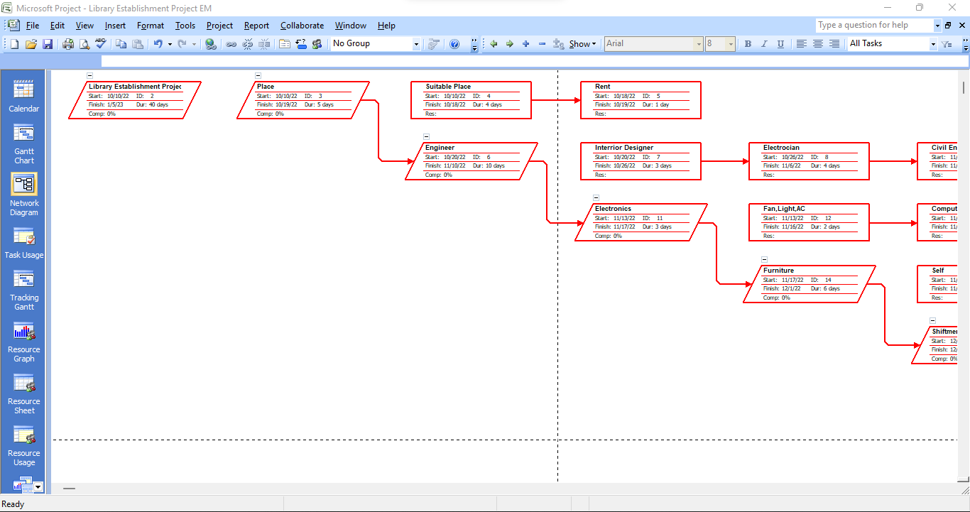

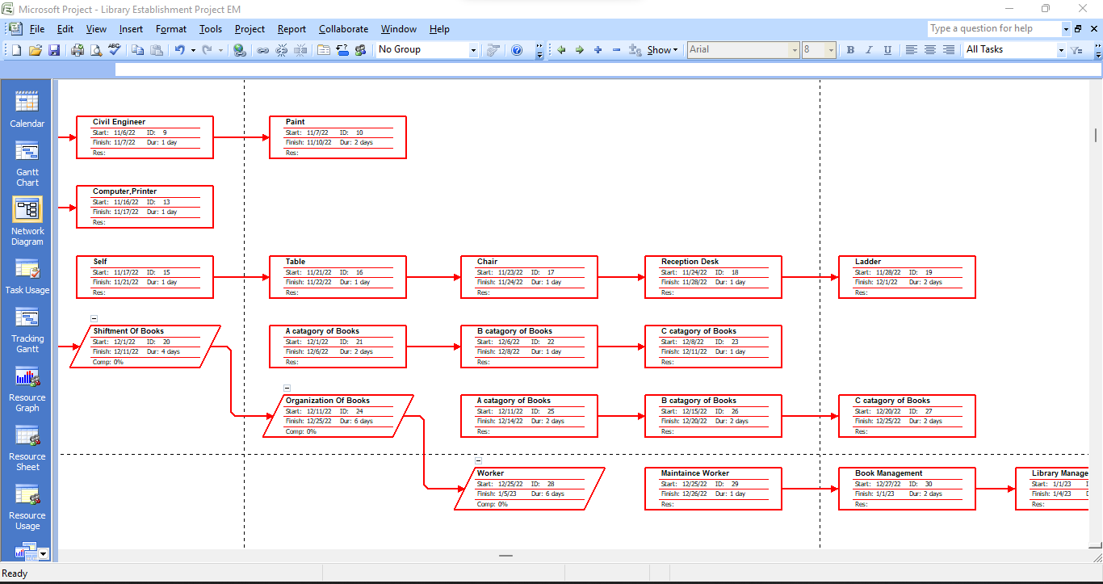

**CRITICAL PATH**

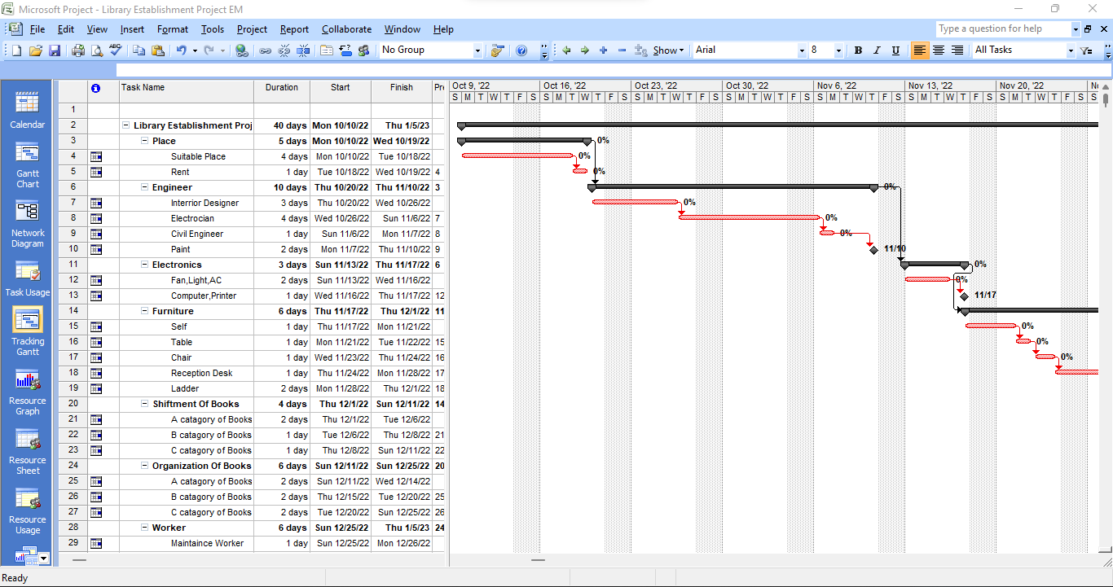

**CONCLUSION AND RECOMMENDATION**

In response to our customer's request, our aim was to create a library. We finished the job and gave the finest performance. The library is tastefully decorated and provided with all required cutting-edge equipment for individualized research. Amazing work was done by our design team. They managed to showcase a lot of library’s aesthetic items in addition to creating a very fashionable environment. Within two months, our knowledgeable staff began the task and completed it on schedule. Knowing how to manage a budget can be useful for professionals in almost any industry. And while the work of our team is frequently only one part of managing the budget, we have been able to finish this project by keeping lines of communication open. We have achieved -

Milestones-

|  |  |
| --- | --- |
| Task | Milestones |
| Engineering part | Finished within 2 weeks |
| Cost Reduction | By 20% |
| Book Organization | Finished within a week |
| Time Management | Perfect |

**REFERENCES:**

* <https://www.youtube.com/watch?v=QIIwF1n5DPc&list=LL&index=7&t=3950s>
* <https://www.daitm.org.in/wp-content/uploads/2019/04/Gr.-06library-project-report.pdf>